**DS04 Activity 5 : Train a Regression Model**

To predict a numeric value, such as the number of minutes delayed or early a flight arrives, train a regression model. Perform the following tasks to train a regression model:

Perform the following tasks to train a regression model:

Task 1: Return to the Azure Machine Learning experiment you created in Part 1.

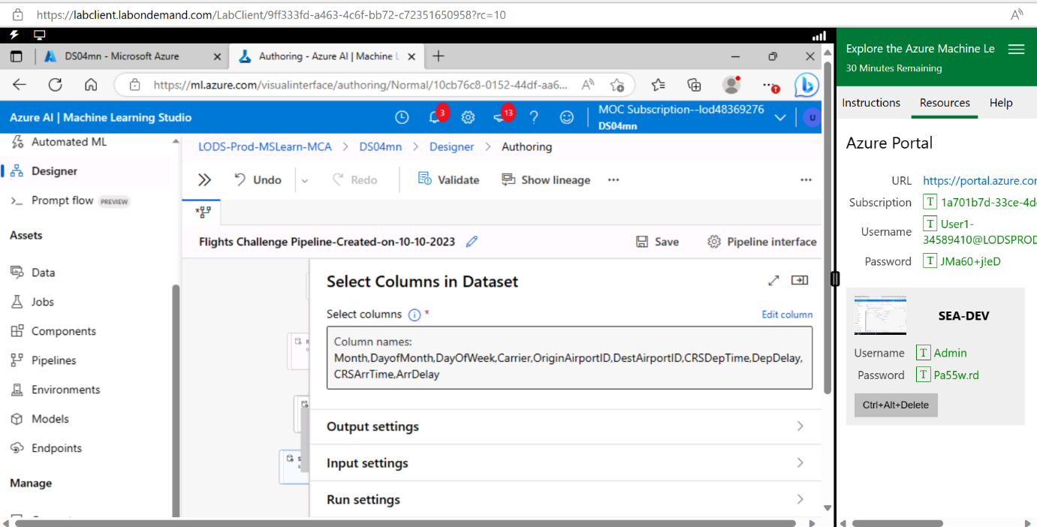Task 2: Add a **Select Columns in Dataset** module, and use it to select only the **Month, DayofMonth, DayOfWeek, Carrier, OriginAirportID, DestAirportID, CRSDepTime, DepDelay, CRSArrTime,** and **ArrDelay** columns.

Task 3: Add an **Edit Metadata** module and use it to make the **OriginAirportID, DestAirportID,** and **Carrier** columns **Categorical.**

Task 4: Add **a Normalize Data** module and use it to standardize the **CRSDepTime, CRSArrTime,** and **DepDelay** columns using the **Z score** transformation method.

Task 5: Add a **Split Data** module and use it to split the rows into **70% / 30%** subsets. Use a random seed value of 0

Task 6: Add a **Boosted Decision Tree Regression** module and a **Train Model** module. Then use the default settings to train the model with the 70% data split to predict the **ArrDelay** label column.

Task 8: Add an **Evaluate Model** module and use it to evaluate the results from the Score Model module.

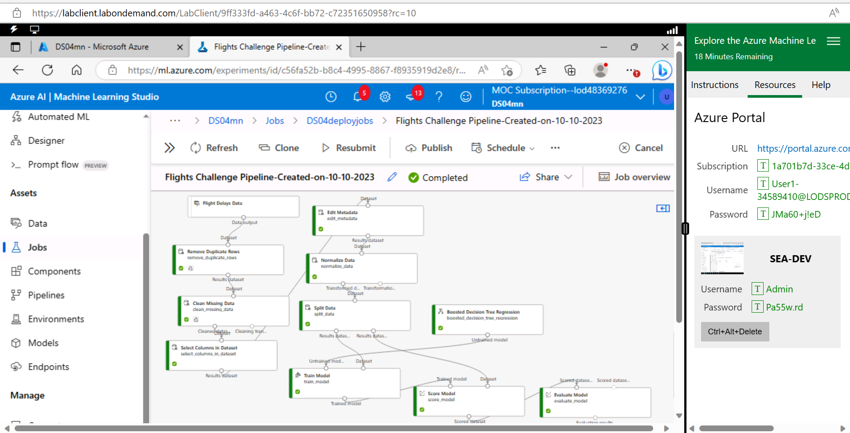

**Take Note**! After Activity 5, the experiment will continue with Activity 6, for Matric and preview

The "Flights Challenge" in Azure Machine Learning was undertaken to leverage the power of Azure's machine learning capabilities. It aimed to train a regression model to predict flight arrival delays, a task that can have significant implications in the aviation industry. By using Azure ML, we could perform data preprocessing, model training, and evaluation in a streamlined and efficient manner. This challenge allowed us to harness the tools and features of Azure ML to develop predictive models for a real-world scenario, ultimately demonstrating the practical applications of machine learning in solving complex problems like predicting flight delays.